**bicycle infrastructure**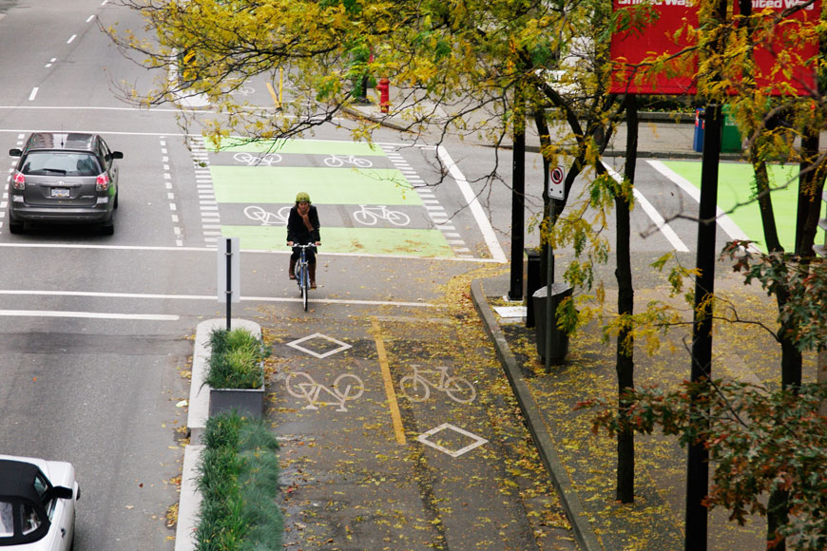

* e-bikes travel time benefits is higher if a common value-of-time is used.
* Bicycle infrastructure may be designed to benefit specific technologies. This generally means that a dedicated route choice is required for every technology where travel time is measured by accumulating travel time for all link types and by measuring waiting time at stops and crossings.
* the extensive Copenhagen bicycle lane network has caused the number of bicycle trips and the bicycle kilometers traveled to increase by 60% and 90%, respectively, compared with a counterfactual without the bicycle lane network. This translates into an annual benefit of €0.4M per km of bicycle lane owing to changes in generalized travel cost, health, and accidents. Our results thus strongly support the provision of bicycle infrastructure.
* Conventional bikes have higher positive health effects and lower safety risks.
* reducing the impact of urban transportation on climate.
* it improves public health and reduce traffic congestion, noise, and air pollution.
* Neighborhoods designed to support walking, cycling and public transport use foster positive social connections, promote feelings of safety and belonging, stimulate local business activity and can reduce the environmental impacts associated with car emissions and traffic congestion… increasing the share of trips made using sustainable transport modes (such as walking and cycling) is imperative.
* to continue to be a globally connected and competitive city with strong and healthy communities and higher social and economic participation, the share of trips by public transport, as well as active transport modes such as walking and cycling, must increase.
* bike lanes are proliferating
* Our analysis also shows that the baseline length of the bike lane network per capita is correlated with a lower treatment effect. We interpret this as an indication that the pop-up bike lane effect is a phenomenon of catch-up growth in cities with a high cycling potential that was previously impeded by missing infrastructure.